

|  |
| --- |
| Masa-Ngwedi EMP E,  The Proposed Construction of a 40km 400kV and 765kV Powerline  DRAFT Wetland Input Report  November 2013  Drafted by  Limosella Consulting  P.O. Box 32733, Waverley  Pretoria, 0135  Email: [antoinette@limosella.co.za](mailto:antoinette@limosella.co.za)  Cell: +27 83 4545 454    Prepared for Mandara Consulting Solutions (pty) Ldt.  Gartner House, 31-33 Wessel Road Rivonia, 2128  P O Box 3203, Rivonia 2128  Tel: 081 3833 453 / 011 234 8485  Fax: 086 5488 052  Email: mandaraconsulting@gmail.com  Co.Reg: 2010-004816-07  VAT 4100242108 |

**Declaration of Independence**

I, **Antoinette Bootsma**, in my capacity as a specialist consultant, hereby declare that I -

* Act as an independent consultant;
* Do not have any financial interest in the undertaking of the activity, other than remuneration for the work performed in terms of the National Environmental Management Act, 1998 (Act 107 of 1998);
* Undertake to disclose, to the competent authority, any material information that has or may have the potential to influence the decision of the competent authority or the objectivity of any report, plan or document required in terms of the National Environmental Management Act, 1998 (Act 107 of 1998);
* As a registered member of the South African Council for Natural Scientific Professions, will undertake my profession in accordance with the Code of Conduct of the Council, as well as any other societies to which I am a member; and
* Based on information provided to me by the project proponent, and in addition to information obtained during the course of this study, have presented the results and conclusion within the associated document to the best of my professional judgement.

|  |  |
| --- | --- |
| ________________________  **Antoinette Bootsma (PrSciNat)**  Ecologist/Botanist  SACNASP Reg. No. 400222-09 | ________________________  Date |

**Indemnity**

This report is based on survey and assessment techniques which are limited by time and budgetary constraints relevant to the type and level of investigation undertaken. The findings, results, observations, conclusions and recommendations given in this report are based on the author’s best scientific and professional knowledge as well as available information at the time of study. Therefore, the author reserves the right to modify aspects of the report including the recommendations if and when new information may become available from ongoing research or further work in this field, or pertaining to this investigation.

Although the author exercises due care and diligence in rendering services and preparing documents, she accepts no liability, and the client, by receiving this document, indemnifies the author against all actions, claims, demands, losses, liabilities, costs, damages and expenses arising from or in connection with services rendered, directly or indirectly by the author and by the use of this document.

TABLE OF QUALIFICATION OF SPECIALISTS

|  |  |  |
| --- | --- | --- |
| Report writing assistance and review | Rudi Bezuidenhoudt  Wetland specialist / Ecologist  SACNASP Reg. No. 500024/13  Antoinette Bootsma  Ecologist/Botanist/Wetland specialist  SACNASP Reg. No. 400222-09  Antoinette Eyssell  Terrestrial Ecologist / Wetland assistant  SACNASP Reg. No. 400019/11 | Antoinette Bootsma (PrSciNat)  Ecologist/Botanist/Wetland specialist  _______________  22 November 2013  Date |
| Field work and data analysis | Rudi Bezuidenhoudt  Wetland specialist / Ecologist  SACNASP Reg. No. 500024/13 |

EXECUTIVE SUMMARY

Limosella Consulting was appointed by Mandara Consulting Solutions to undertake a walk down of the proposed powerline Masa-Ngwedi 765kV and Masa-Ngwedi 400kV and provide input into the Environmental Management Plan with regards to the presence and outer edge of wetlands or riparian areas that should be avoided or impacts mitigated during the construction of the powerline route. This report covers the final 40km of the proposed route for the towers 341-436 (765kV) and 327-417 (400kV).

The terms of reference were as follows:

* Conclusively identify the presence or absence of wetland and riparian conditions as prescribed by the DWAF (2005) delineation guideline;
* Identify the outer edge of the wetland temporary zone and recommend a suitable buffer zone for wetlands that may be affected by the proposed powerline alignments and substation;
* Discuss suitable buffer zones;
* Indicate possible impacts that the proposed activity could have on the wetlands/riparian areas if present; and
* Recommend mitigation measures in order to limit the impact of the proposed development.

One riparian area and three wetland areas were recorded on this section of the proposed line. The riparian area and its associated drainage lines and tributaries extend along the majority of the proposed 40km line and transverses the line in several places. The riparian area also flows parallel with the proposed line for approximately 17km. The majority of the riparian vegetation is intact and creates a sufficient buffer against natural erosional and sedimentation. However should this vegetation be removed it is likely that erosion and sedimentation will increase in those areas. The majority of the drainage lines discussed are non-perennial drainage lines while the main river channel appears to be a perennial river. The wetlands recorded have been somewhat disturbed by anthropogenic activities including roads, farming and water treatment facilities. All the wetland areas further show signs of grazing. Construction activities have taken place in two of the wetland areas and thus have resulted in a lower Present Ecological Status scores for these wetland areas.

The following table indicates all the towers within 500m and/or 100m from the watercourses as well as the areas where the line will need to span across a watercourse. The towers within 500m from a watercourse are indicated for mitigation purposes, as a 500m buffer zone from the edge of the riparian area is considered as potentially sensitive to activities associated with construction. All the towers within a 100m buffer zone are highlighted due to potential implications of General Notice 1199 of the National Water Act, 1998 (Act 36 of 1998) and may require a water use license. This legislation is also applicable to activities (including access roads) that are located within the 1:100 year floodline or riparian habitat (whichever is the greatest) (DWA, 2010).

| **Tower number**  **(756kV)** | **Tower Number**  **(400kV)** | **Classification of Watercourses (NWA, 1998) observed during the field survey** | **Notes** | **Present Ecological State (PES) \*** |
| --- | --- | --- | --- | --- |
| 341 | 327 | * Within 500m from a drainage line | * Should be regarded as sensitive area. * Follow best practice principles | **C** |
| 342 | 328 | * Within 100m of a drainage line. * 342 Located directly within the drainage line | * Tower 342 should be moved so it is not located directly within the drainage line. * Mitigation for erosion should be followed. * Where necessary, soil compaction, sedimentation and loss of natural vegetation should be rehabilitated. * Monitor for establishment of alien invasive vegetation. | **C** |
| 343, 344, 345 | 329, 330, 331 | * Within 500m of a riparian area. | * On the 765kV line the line will span the riparian area between the following towers: 342 & 343. * On the 400kV line the line will span the riparian area between the following towers: 328 & 329. * Care should be taken not to drive though these areas. * Where necessary, soil compaction and loss of natural vegetation should be rehabilitated. | **C** |
| 345, 346, 347 | 331, 332, 333 | * Within 500m of a drainage line. | * Follow best practice principles | **C** |
| 351, 352, 353, 354, 355, 356, 357, 358,359, 360, 361, 362, 363, 364 | 336, 337, 341, 342, 344, 345, 346, 347 | * Within 500m of a drainage line. | * On the 765kV line the line will span the drainage line between the following towers: 351 & 352, 358 & 361, 362 &363. * On the 400kV line the line will span the drainage line between the following towers: 336 & 337, 342 & 344, 346 & 347. * Care should be taken not to drive though these areas. * Where necessary, soil compaction and loss of natural vegetation should be rehabilitated. | **C** |
| 358, 360 | 342, 344, 346 | * Within 100m of the Drainage Line | * Erosion mitigations should be followed. | **C** |
| 359 | 343 | * Located directly within a drainage line. | * Towers should be moved so it is not located directly within the drainage line. * Mitigation for erosion should be followed. * Where necessary, soil compaction, sedimentation and loss of natural vegetation should be rehabilitated. * Monitor for establishment of alien invasive vegetation. | **C** |
| 373, 374, 375, 376 | 356, 357, 358, 359 | * Located within 500m of an unchannelled valley bottom wetland. | * On the 765kV line the line will span the wetland between the following towers: 373 & 375 * On the 400kV line the line will span the wetland between the following towers: 357 7 358. * Care should be taken not to drive though these areas. * Where necessary, soil compaction and loss of natural vegetation should be rehabilitated. | **C** |
| 374 |  | * Located directly within a unchannelled valley bottom wetland | * Tower should be moved so it is not located directly within the wetland or its buffer zone. * Mitigation for erosion should be followed. * Where necessary, soil compaction and loss of natural vegetation should be rehabilitated. | **C** |
| 376, 377, 378 | 359, 360, 361 | * Located within 500m of a seepage wetland. | * On the 765kV line the line will span the wetland including its buffer zone between the following towers: 377 & 378 * On the 400kV line the line will span the wetland and its buffer zone between the following towers: 360 & 361. * Care should be taken not to drive though these areas. * Where necessary, soil compaction and loss of natural vegetation should be rehabilitated. | **C/D** |
| 391, 392, 393, 394 | 373, 374, 375 | * Located within 500m of a seepage wetland | * On the 765kV line the line will span the wetland and its buffer zone between the following towers: 391 & 393. * On the 400kV line the line will span the wetland and its buffer zone between the following towers: 373 & 374. * Care should be taken not to drive though these areas. * Where necessary, soil compaction and loss of natural vegetation should be rehabilitated. | **C** |
| 392 | 374 | * 392 Located directly within a seepage wetland. * 374 located very close to a seepage wetland. | * Towers should be moved so they are not located directly within the wetland or its buffer. * Where necessary, soil compaction and loss of natural vegetation should be rehabilitated. * Mitigation for erosion should be followed. | **C/D** |
| 392, 393, 394 | 374, 375 | * Located within 500m of a riparian area. | * On the 765kV line the line will span the riparian area between the following towers: 393 & 394. * On the 400kV line the line will span the riparian area between the following towers: 374 & 375. * Care should be taken not to drive though these areas. * Where necessary, soil compaction and loss of natural vegetation should be rehabilitated. | **C** |
| 393 | 375 | * Located within 100m of a riparian area. | * Mitigation for erosion should be followed. | **C** |
| 399, 400, 401, 402, 403, 404 | 380, 381, 382, 383, 384, 385 | * Located within 500m of a riparian area | * On the 765kV line the line will span the riparian area between the following towers: 401 & 402, 403 & 404. * On the 400kV line the line will span the riparian area between the following towers: 380 & 381, 383 & 384. * Care should be taken not to drive though these areas. * Where necessary, soil compaction and loss of natural vegetation should be rehabilitated. | **C** |
| 400, 401, 403, 404 | 381, 383, 384 | * Located within 100m of a riparian area. | * Mitigation for erosion should be followed. | **C** |
| 409, 410, 411 | 389, 390 | * Located within 500m of a drainage line. | * On the 765kV line the line will span the drainage line between the following towers: 409 & 410. * On the 400kV line the line will span the drainage line between the following towers: 389 & 390. * Care should be taken not to drive though these areas. | **C** |
| 410 |  | * Located within 100m of a drainage line. | * Mitigation for erosion should be followed. | **C** |
| 414, 415 | 393, 394 | * Located within 500m of a drainage line | * On the 765kV line the line will span the drainage line between the following towers: 414 & 415 * On the 400kV line the line will span the drainage line between the following towers: 393 & 394. * Care should be taken not to drive though these areas. * Where necessary, soil compaction and loss of natural vegetation should be rehabilitated. | **C** |
| 414 | 393 | * Located within 100m of a drainage line. | * Mitigation for erosion should be followed. | **C** |
| 414, 415, 416, 417, 418, 419, 420, 421, 422, 423, 424, 425, 426, 427, 428, 429, 430, 431, 432, 433, 434, 435 | 393, 394, 395, 396, 397, 398, 399, 400, 401, 402, 403, 404, 405, 406, 407, 408, 409, 410, 411, 413, 414, 415, 416, 417 | * Located within 500m of a riparian area or one of the associated tributaries or drainage lines. | * On the 765kV line the line will span the riparian area between the following towers: 417 & 418, 422 & 423, 424 & 425, 426 & 427, 428 & 429, 432 & 433, 433 & 434. * On the 400kV line the line will span the riparian area between the following towers: 393 & 394, 402 & 403, 404 & 405, 406 & 407, 408 & 409, 412 & 414. * Care should be taken not to drive though these areas. * Where necessary, soil compaction and loss of natural vegetation should be rehabilitated. | **C** |
| 417, 418, 422, 423, 424, 427, 428, 429, 433 | 397, 398, 407, 408, 409, 414 | * Located within 100m of a riparian area or one of the associated tributaries or drainage lines. | * Mitigation for erosion should be followed. | **C** |
| 425 | 405, 413 | * Located directly within a riparian area or one of the associated tributaries or drainage lines. | * Towers should be moved so it is not located directly within the drainage line. * Mitigation for erosion should be followed. | **C** |

The towers that are likely to have the largest impacts on the watercourses recorded are those that are located directly within the watercourse (765kV Tower Numbers: 342, 359, 374, 392, 425 and 400kV Tower Numbers: 343, 374, 405, and 413). Ideally these towers should be moved out of the watercourse to minimise potential erosion and sedimentation. The towers that will need to span watercourses are: 765kV Tower Numbers: 342, 343, 351, 352, 358-363, 373, 375, 377, 378, 391-394, 401-404, 409, 410, 415-418, 422-429, 432-434 and 400kV Tower Numbers: 328, 329, 336, 337, 342-344, 346, 347, 357, 358, 360, 361, 373, 374, 375, 380, 381, 383, 384, 389, 390, 393, 394, 402-409, 412-414. Care should be taken not to drive through these watercourses as it is likely to cause erosion, soil compaction sedimentation and loss of vegetation.

In order to limit the impact on the hydrology of the area, the current assessment finds that a 50m buffer zone should be recognised from the edge of all wetland areas as 100m from the edge of riparian areas. Powerline infrastructure should ideally be excluded from these sensitive areas. However, linear developments such as the proposed powerline are rarely able to avoid crossing any watercourses whatsoever. Where alternatives have been investigated and watercourse crossings have been shown to be necessary it is important that appropriate mitigation measures are put into place and carefully monitored to ensure minimal impact to regional hydrology. In the case of the proposed powerline mitigation should focus on:

* Rehabilitation / restoration of indigenous vegetative cover;
* Management of point discharges during construction activities;
* Alien plant control;
* Implementation of best management practices regarding stormwater and earthworks;
* Provision of adequate sanitation facilities located outside of the wetland/riparian area or its associated buffer zone during construction activities;
* Implementation of appropriate stormwater management around the excavation to prevent the ingress of run-off into the excavation; and
* Prevention of erosion, and where necessary rehabilitation of eroded areas.

The impact assessment found that the greatest impact that the construction of the power line is likely to have on the assessed watercourses is the change in the amount of sediment entering the water resources and associated change in turbidity (increasing or decreasing the amount) during construction. Loss of wetland habitat is another concern. Mitigation measures as set out in this report should be strictly adhered to as well as the accompanying general rehabilitation and monitoring plan.

Table of Contents

1 INTRODUCTION 13

1.1 Terms of Reference 13

1.2 Assumptions and Limitations 13

1.3 Definitions and Legal Framework 13

1.4 Locality of studied routes 14

1.5 Description of the Receiving Environment 15

2 METHODOLOGY 17

3 RESULTS 18

3.1 Wetland and riparian Classification 18

3.2 Discussion 19

4 Buffer Zones 25

4.1 Wetland input into Environmental Management Plan (EMP) 26

5 CONCLUSION 36

6 REFERENCES 43

Appendix A: Location of Survey Points 45

Appendix B: Glossary of Terms 45

Figures

Figure 1: Presence of hydrological features as per existing hydrology layers. 16

Figure 2: Typical cross section of a wetland (Ollis et al, 2013) 18

Figure 3: Schematic diagram illustrating the structures characteristic of riparian conditions (Kleynhans et al.2007) 19

Figure 4: Wetlands and riparian areas identified along the proposed line 20

Figure 5: Example of overgrazing within the unchannelled valley bottom wetland. 21

Figure 6: Example of a drainage line with terrestrial vegetation. 23

Figure 7: Main channel of the perennial river. 24

Figure 8: Sampling point map 45

Tables

Table 1: Land types along the proposed powerline alignment. 17

Table 2: Health categories used by WET-Health for describing the integrity of wetlands (Macfarlane et al, 2007) 22

Table 3: Generic ecological categories for EcoStatus components (modified from Kleynhans, 1996 & Kleynhans, 1999) 24

Table 4: Generic functions of buffer zones relevant to the study site (adapted from Macfarlane et al, 2010) 25

Table 5: The impacts associated with the various watercourses along the power line. 26

Table 6: Minimum suggested mitigation measures. 31

Table 7: Impacts and suggested management procedures relevant to the proposed development (modified from Macfarlane et al, 2010) 33

Table 8: The impacts associated with the various watercourses along the power line 37

# INTRODUCTION

Limosella Consulting was appointed by Mandara Consulting Solutions to undertake a walk down of the proposed powerline Masa-Ngwedi 765kV and Masa-Ngwedi 400kV and provide input with regards to the presence and outer edge of wetlands that should be avoided or impacts mitigated during the construction of the powerline route. This report covers the final 40km of the proposed route for the towers 341-436 (765kV) and 327-417 (400kV). The approximate starting coordinates are 25° 8'40.81"S and 27°16'47.99"E and the approximate end coordinates are 25°24'17.15"S and 27° 5'13.41"E. Site visits was conducted on 7, 8, 14 and 15 November 2013.

## Terms of Reference

The terms of reference for the current study were as follows:

* Conclusively identify the presence or absence of wetland and riparian conditions as prescribed by the DWAF (2005) delineation guideline;
* Identify the outer edge of the wetland temporary zone and recommend a suitable buffer zone for wetlands that may be affected by the proposed powerline alignments and substation;
* Discuss suitable buffer zones;
* Indicate possible impacts that the proposed activity could have on the wetlands/riparian areas if present; and
* Recommend mitigation measures in order to limit the impact of the proposed development.

## Assumptions and Limitations

The Garmin Montana 650 was used for wetland and riparian delineations is accurate to within five meters. Therefore, the wetland delineation plotted digitally may be offset by at least five meters to either side. Furthermore, it is important to note that, during the course of converting spatial data to final drawings, several steps in the process may affect the accuracy of areas delineated in the current report. It is therefore suggested that the no-go areas identified in the current report be pegged in the field in collaboration with the surveyor for precise boundaries.

Access was denied on various sections along the proposed line and sampling could thus not be conducted on these areas. Due to time constraints emphasise was set on covering the proposed area rather than spending a long time on individual watercourses. Aerial imagery as well as groundtruthing was thus used in the delineation process where adequate sampling could not take place.

A Red Data scan, fauna and flora, and aquatic assessments were not included in the current study. Description of the depth of the regional water table and geohydrological processes falls outside the scope of the current assessment.

## Definitions and Legal Framework

In a South African legal context, the term watercourse is often used rather than the terms wetland, or river. The National Water Act (NWA) (1998) describes a water resource as including a river, stream, dam, spring, aquifer, wetland, lake, and pan.

riparian habitat is the accepted indicator used to delineate the extent of a river’s footprint (DWAF, 2005). The National Water Act, 1998 (Act No. 36 of 1998), defines a riparian habitat as follows: “riparian habitat includes the physical structure and associated vegetation of the areas associated with a watercourse, which are commonly characterised by alluvial soils, and which are inundated or flooded to an extent and with a frequency sufficient to support vegetation of species with a composition and physical structure distinct from those of adjacent land areas.”.

The National Water Act, 1998 (Act 36 of 1998) defines a wetland as “land which is transitional between terrestrial and aquatic systems where the water table is usually at or near the surface, or the land is periodically covered with shallow water, and which land in normal circumstances supports or would support vegetation typically adapted to life in saturated soil.”

Authoritative legislation that lists impacts and activities on wetlands and riparian areas that requires authorisation includes (Armstrong, 2009):

* Conservation of Agriculture Resources Act, 1983 (Act 43 of 1983);
* Environment Conservation Act, 1989 (Act 73 of 1989);
* National Water Act, 1998 (Act 36 of 1998);
* National Forests Act, 1998 (Act 84 of 1998);
* National Environmental Management Act, 1998 (Act No. 107 of 1998);
* National Environmental Management: Biodiversity Act, 2004 (Act 10 of 2004).
* GNR 1182 and 1183 of 5 September 1997, as amended (ECA);
* GN 1199 (Section 39) (2009);
* GNR 544, 545 and 546 of 18 June 2010 (NEMA);
* Section 24(5) (NEMA);
* Section 24(7) (NEMA);
* Section 2 of the ECA.

In addition, note that any wetlands situated within 500m or any riparian areas within 100m of the proposed activity should be regarded as sensitive features potentially affected by the proposed development (Regulation 1199 of the National Water Act, 1998 (Act 36 of 1998) and may require a water use license.

## Locality of studied routes

This section of the proposed Masa Ngwedi power line infrastructure starts at towers 341 (765kV) and 327 (400kV) and ends with the towers 436 (765kV) and 417 (400kV). The start of the proposed power line section is located east of the R510 and approximately 3.5km north of the town of Sandfontein. The approximate coordinates are 25° 8'40.81"S and 27°16'47.99"E. The end of the proposed section is located east of the R565 road and West of the town of Chaneng. The approximate coordinates for the end of the proposed line are 25°24'17.15"S and 27° 5'13.41"E. The proposed line moves south west from the start section to the end section.

## Description of the Receiving Environment

A review of available literature and spatial data formed the basis of a characterisation of the biophysical environment in its theoretically undisturbed state and consequently an analysis of the degree of impact to the ecology of the study site in its current state.

Presence of watercourses based on existing spatial layers

The hydrology layer reflects numerous rivers, tributaries and drainage lines. In the north the proposed line mainly crosses small tributaries and drainage lines. In the south the proposed line crosses larger rivers such as the Elands River and its tributary the Seshabele River. The final section of the proposed line runs parallel with the Elands River for an extended length and often comes within 500m from the river.

The National Freshwater Ecosystem Priority Areas (NFEPA) project does not highlight the potential presence of wetlands in the immediate vicinity of the proposed line (Figure 1).

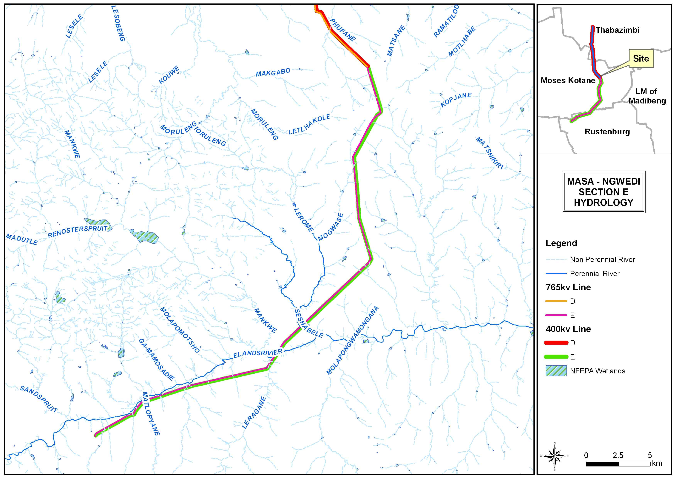

Figure 1: Presence of hydrological features as per existing hydrology layers.

Quaternary Catchment:

The proposed power line falls within 2 Quaternary Catchments. Towers 341-346 (765kV) and towers 327-331 (400kV) fall within the Quaternary Catchment A24E. The towers 347-436 (765kV) and towers 332-417 (400kV) fall within the Quaternary Catchment A22F. Within these two Quaternary Catchments the Mean Annual Precipitation (MAP) is lower than the Potential Evapotranspiration (PET) with a ratio of 0.23 for both Quaternary Catchments. It is therefore likely that wetland systems in this region are groundwater driven as opposed to driven by surface water input. Consequently, wetlands in this area are sensitive to changes in regional hydrology, particularly where their catchment becomes transformed and the water available to sustain them becomes redirected.

Land type and soils

The study is situated in the following land types: Fa4, Fb149 and Ea3. Table 1 summarises these land types.

Table 1: Land types along the proposed powerline alignment.

|  |  |
| --- | --- |
| **Land Type**  **(ENPAT,2001)** | **Image** |
|  |  |
| Fa4  GLENROSA AND/OR MISPAH FORMS (other soils may occur); Lime rare or absent in the entire landscape |

# METHODOLOGY

The delineation method documented by the Department of Water affairs and Forestry in their document “Updated manual for identification and delineation of wetlands and riparian areas” (DWAF, 2008), and the Minimum Requirements for Biodiversity Assessments (GDACE, 2009) as well as the Classification System for Wetlands and other Aquatic Ecosystems in South Africa. User Manual: Inland Systems (Ollis *et al,* 2013) were followed throughout the field survey. These guidelines describe the use of indicators to determine the outer edge of the wetland and riparian areas such as soil and vegetation forms as well as the terrain unit indicator.

A hand held Garmin Montana 650 was used to capture GPS co-ordinates in the field. 1:50 000 cadastral maps and available GIS data were used as reference material for the mapping of the preliminary watercourse boundaries. These were converted to digital image backdrops and delineation lines and boundaries were imposed accordingly after the field survey.

# RESULTS

## Wetland and riparian Classification

Wetlands are identified based on the following characteristic attributes (DWAF, 2008) (Figure 2):

* The presence of plants adapted to or tolerant of saturated soils (hydrophytes);
* Wetland (hydromorphic) soils that display characteristics resulting from prolonged saturation; and
* A high water table that results in saturation at or near the surface, leading to anaerobic conditions developing within 50cm of the soil surface.

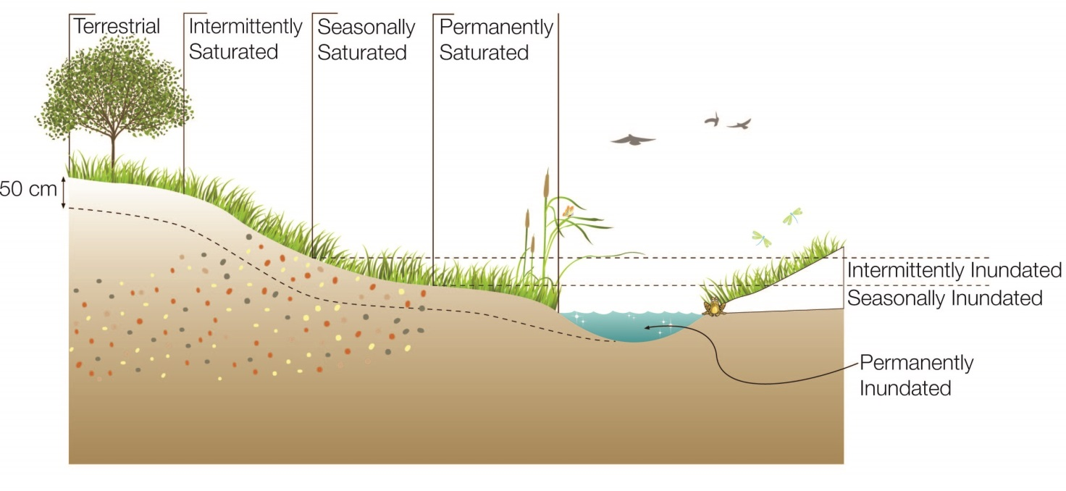

Figure 2: Typical cross section of a wetland (*Ollis et al,* 2013)

Riparian habitat is classified primarily by identifying riparian vegetation along the edge of the macro stream channel. The macro stream channel is defined as the outer bank of a compound channel and should not be confused with the active river bank. The macro channel bank often represents a dramatic change in the energy with which water passes through the system. Rich alluvial soils deposit nutrients making the riparian area a highly productive zone. This causes a very distinct change in vegetation structure and composition along the edges of the riparian area. The marginal zone has also been referred to as active features or wet bank (Van Niekerk and Heritage, 1993). It includes the area from the water level at low flow, if present, to those features that are hydrologically activated for the greater part of the Year (WRC Report No TT 333/08 April, 2008). The non-marginal zone is the combination of the upper and lower zones (Figure 3).

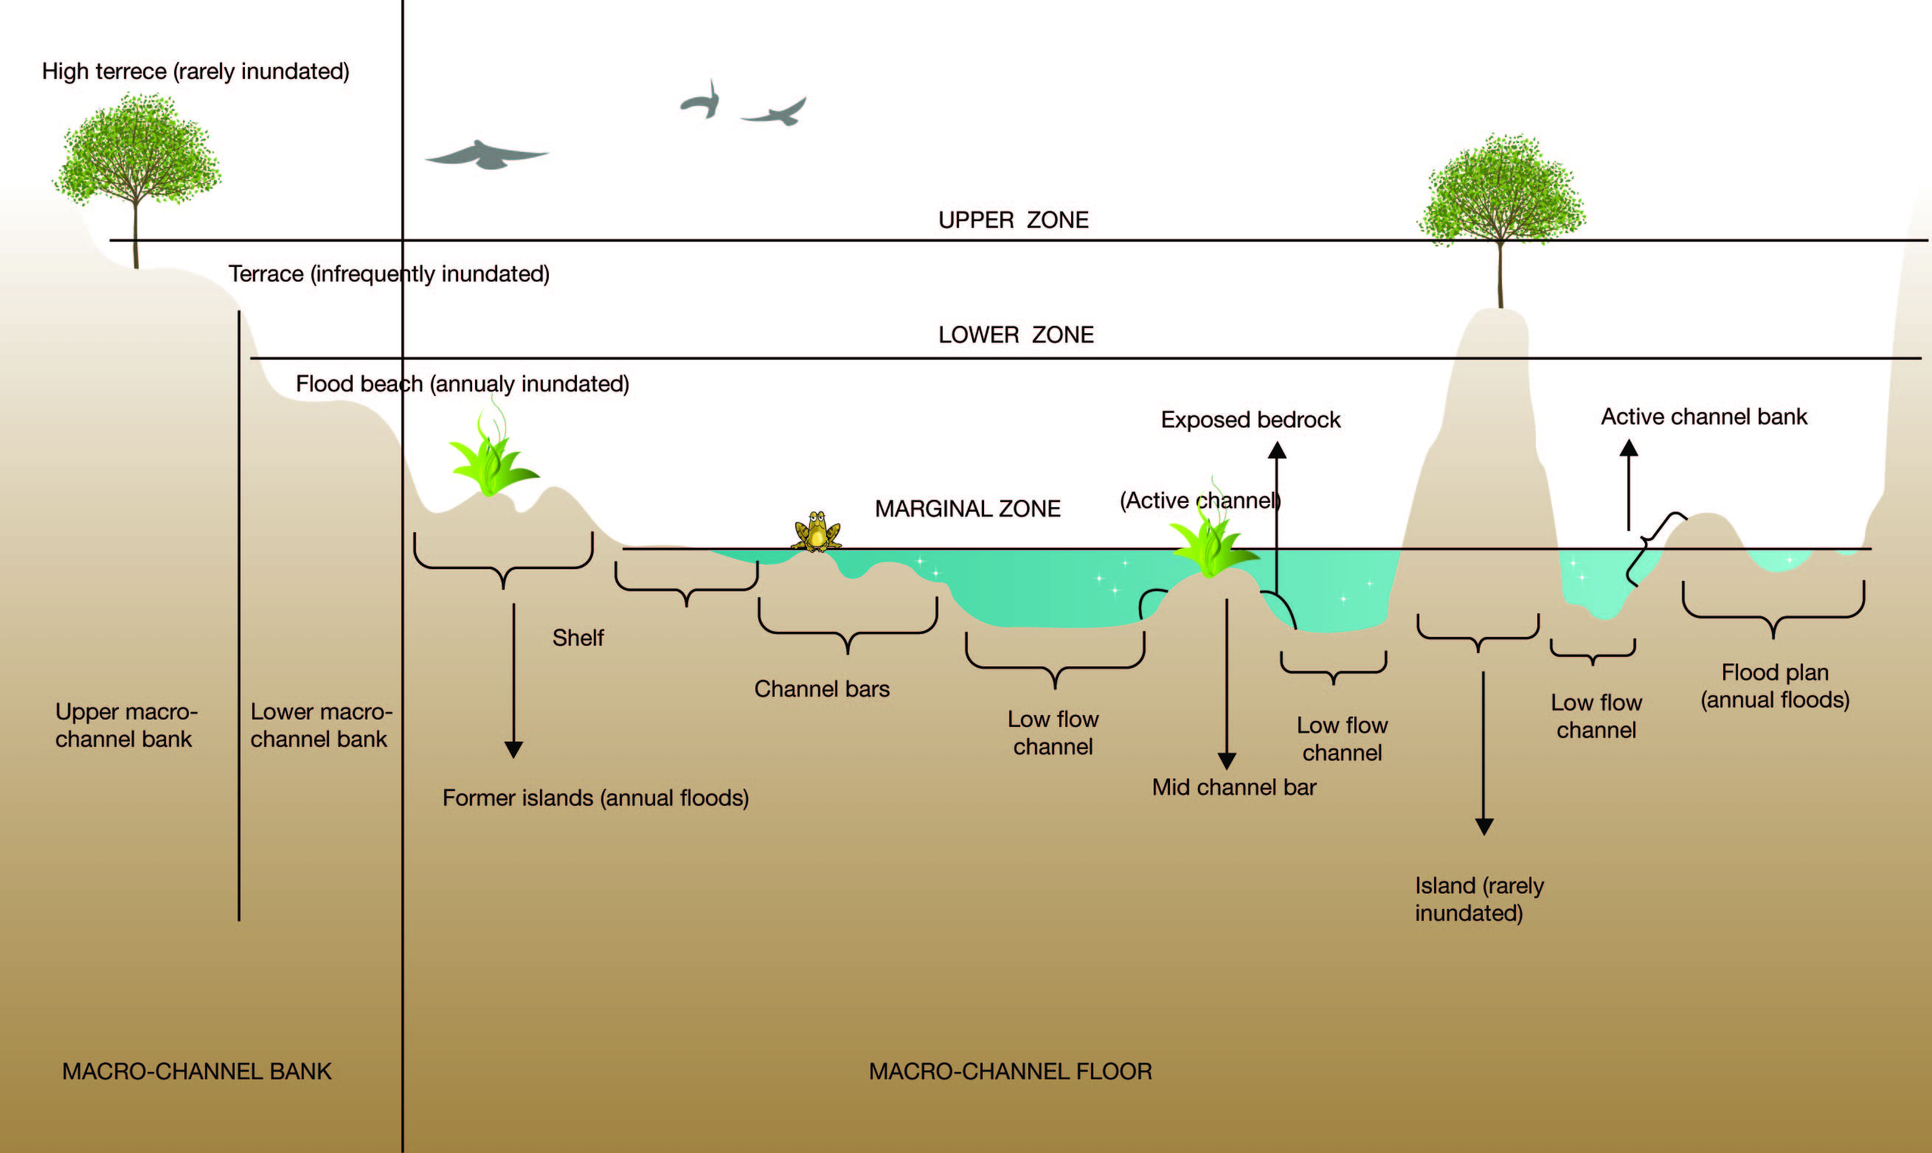

Figure 3: Schematic diagram illustrating the structures characteristic of riparian conditions (Kleynhans *et al.2007*)

## Discussion

Throughout the proposed line three (3) wetland areas and one (1) riparian area were recorded. The wetland areas are further classified as an unchannelled valley bottom wetland and two seepage wetlands (Figure 4).

Drainage lines were also mapped although they do not fall into the definition of either wetland or riparian habitat. They do however form part of the hydrological environment and as such should be considered as sensitive features.

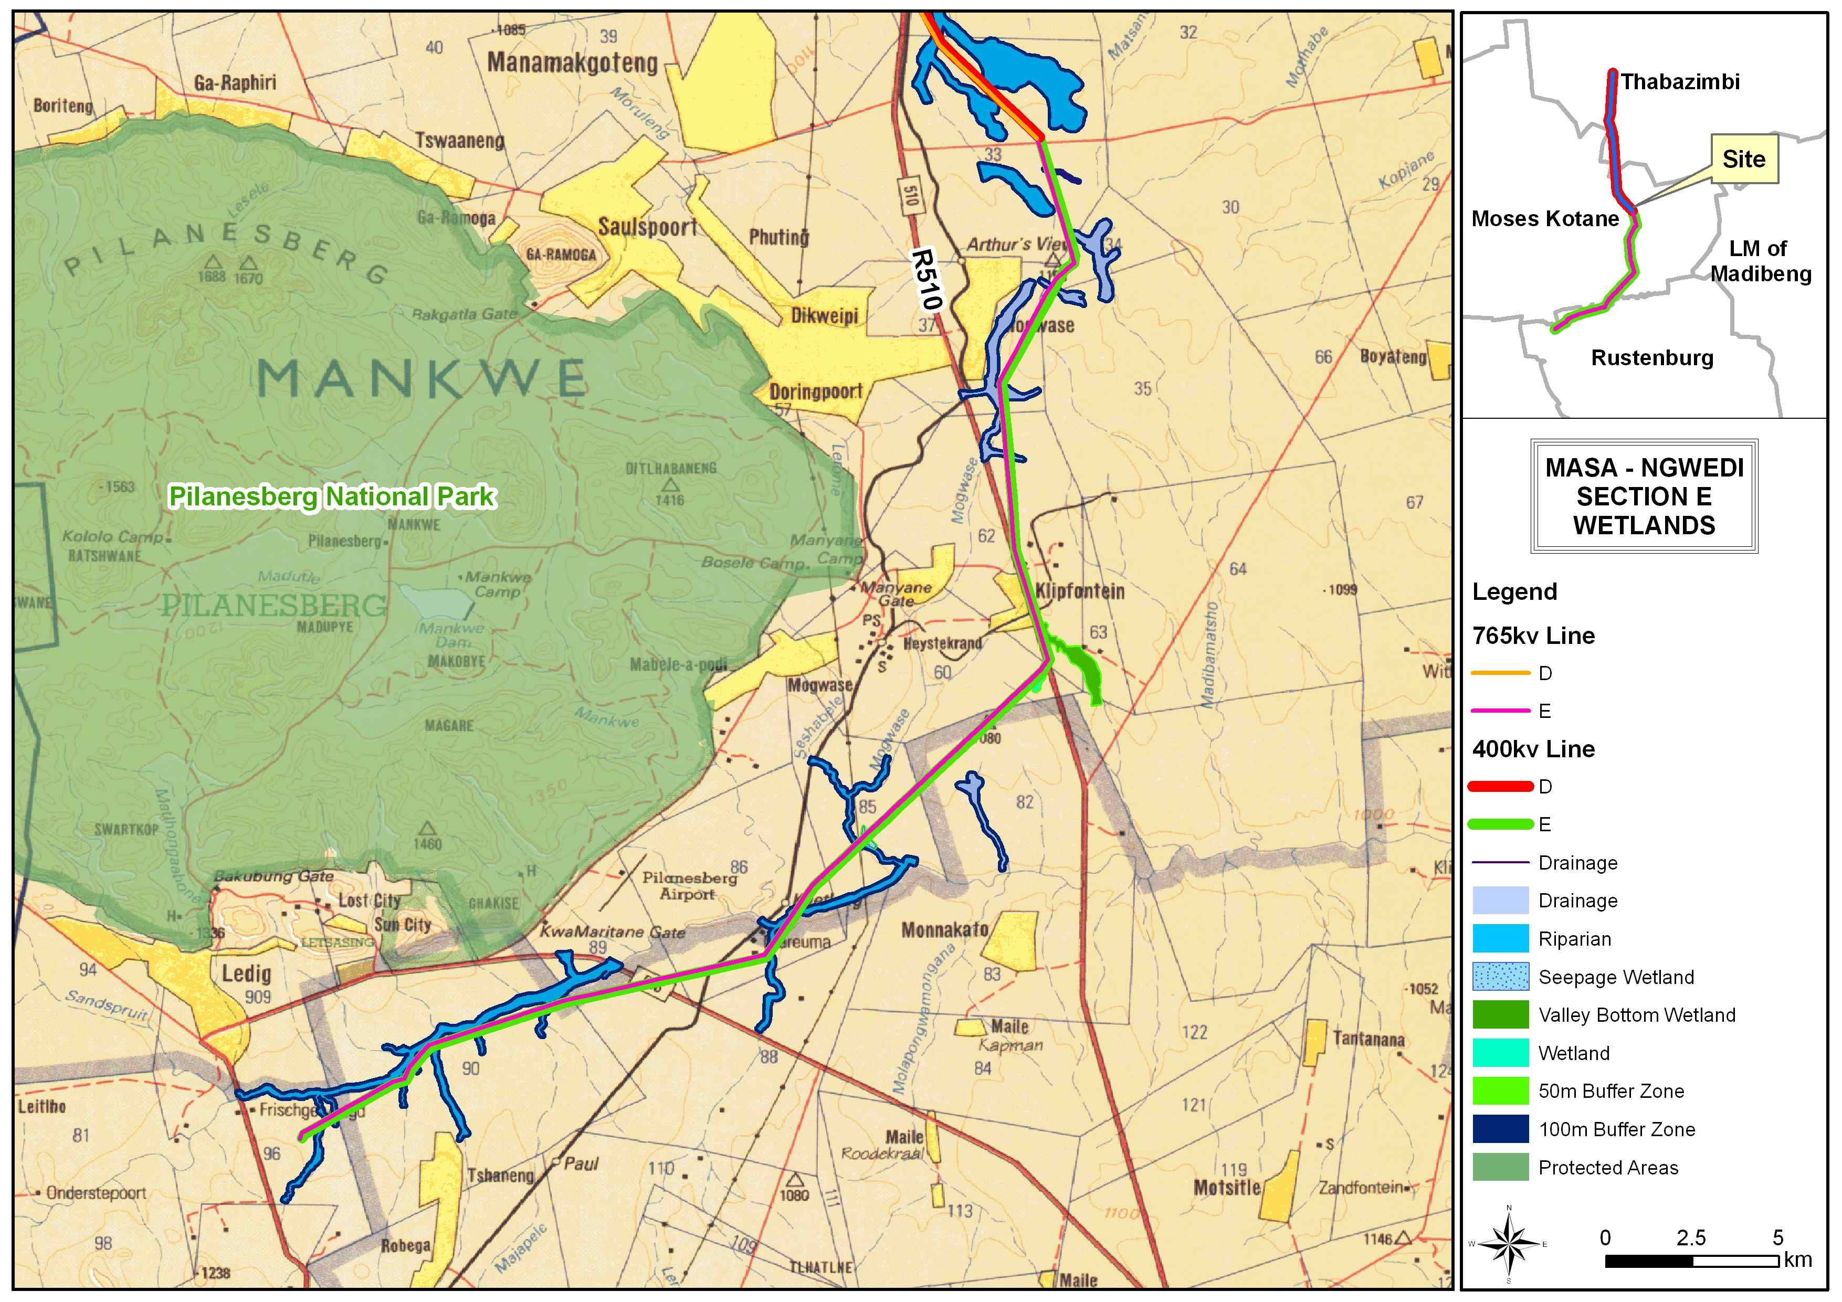

Figure 4: Wetlands and riparian areas identified along the proposed line

The unchannelled valley bottom wetland was located on shallow bedrock in some parts and was grazed in large areas (Figure 5). Various anthropogenic activities such as construction and farming have taken place in and around this wetland area. The two seepage wetlands have also been impacted by activities such as construction and farming. The one seepage wetland is located adjacent a water treatment plant. The vegetation of the wetland areas include:

* *Imperata cylindrica;*
* *Juncus rigidus;*
* *Paspalum urvillei;*
* *Isolepis incomtula.*

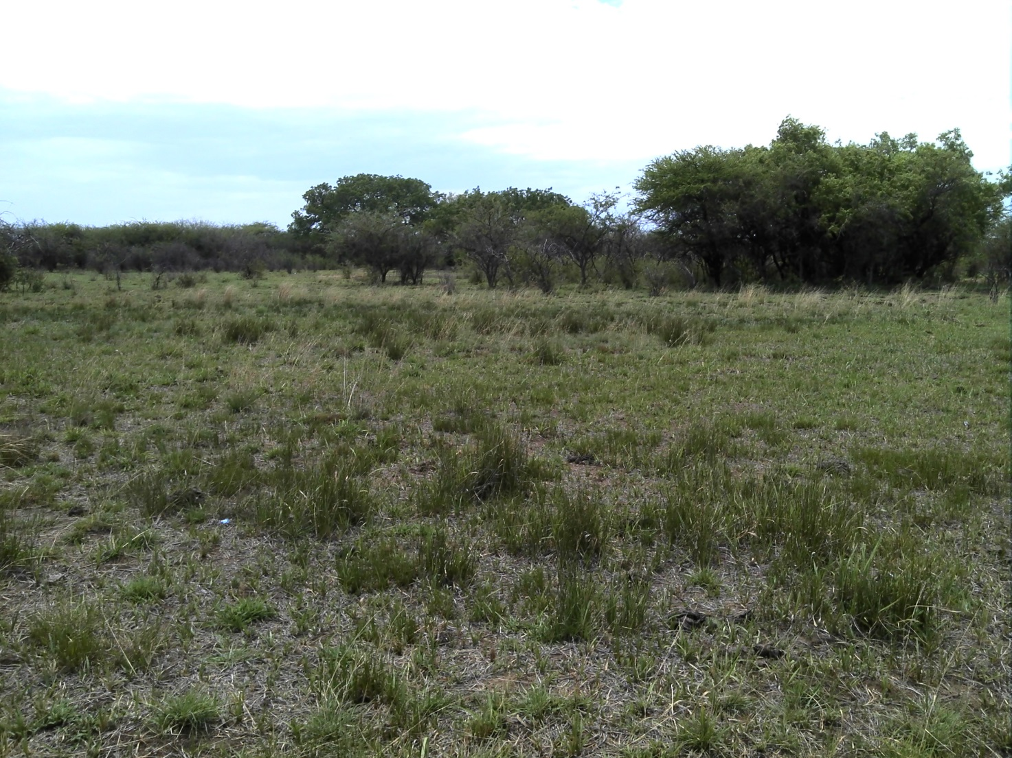

Figure 5: Example of overgrazing within the unchannelled valley bottom wetland.

A level 1 health assessment was done for the wetlands recorded. The PES (Present Ecological State) scores of the unchannelled valley bottom are: C/D, for the first seepage wetland: C and for the last seepage wetland: C/D. Table 2 provides descriptions of the PES scores obtained during this assessment.

Table 2: Health categories used by WET-Health for describing the integrity of wetlands (Macfarlane *et al*, 2007)

| **Description** | **Impact Score Range** | **PES Score** | **Summary** |
| --- | --- | --- | --- |
| Unmodified, natural. | 0.0.9 | A | Very High |
| Largely natural with few modifications. A slight change in ecosystem processes is discernible and a small loss of natural habitats and biota may have taken place. | 1-1.9 | B | High |
| **Moderately modified. A moderate change in ecosystem processes and loss of natural habitats has taken place but the natural habitat remains predominantly intact.** | **2-3.9** | **C** | **Moderate** |
| **Largely modified. A large change in ecosystem processes and loss of natural habitat and biota has occurred.** | **4-5.9** | **D** | **Moderate** |
| The change in ecosystem processes and loss of natural habitat and biota is great but some remaining natural habitat features are still recognizable. | 6-7.9 | E | Low |
| Modifications have reached a critical level and the ecosystem processes have been modified completely with an almost complete loss of natural habitat and biota. | 8.10 | F | Very Low |

The riparian area consists of numerous drainage lines and tributaries which forms part of the same river system. Due to the extensive nature of a riparian system, the same system comes within 500m of the proposed line numerous time as well as crossing numerous drainage lines and tributaries of the riparian system. The majority of the riparian habitat remains intact and thus minimises erosion and sedimentation into the river, however in areas where the riparian habitat has been compromised by e.g bush clearing, erosional features could be seen. Most of the recorded drainage lines throughout the proposed line were non-perennial drainage and thus were dominated by terrestrial vegetation (Figure 6).

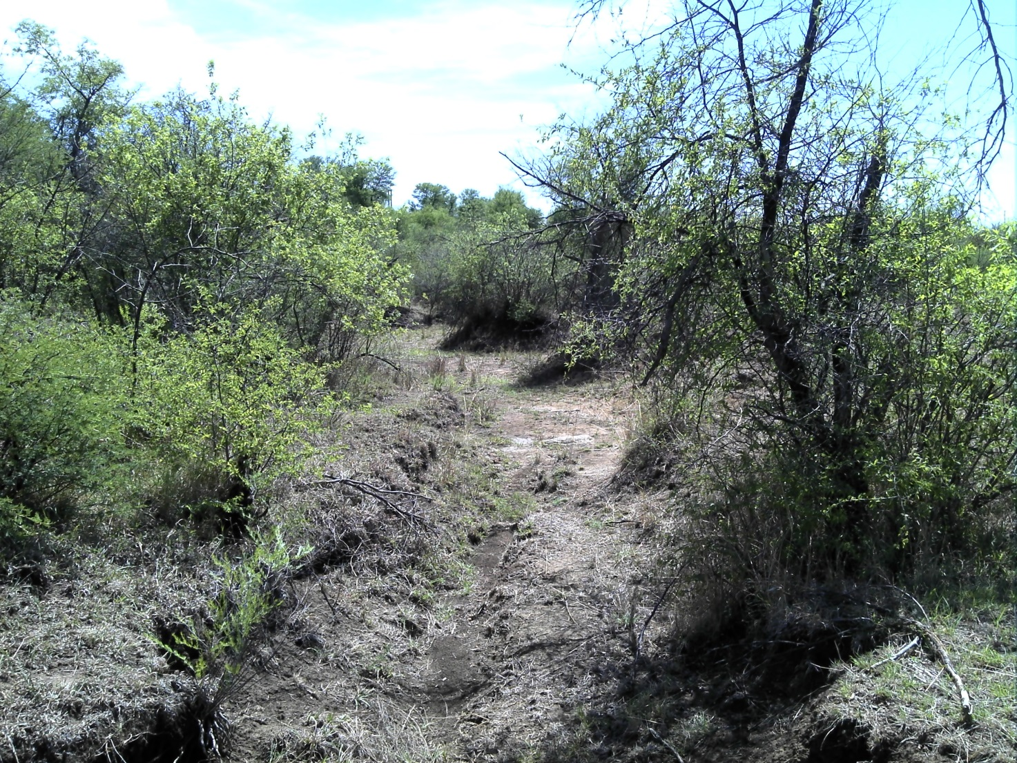

Figure 6: Example of a drainage line with terrestrial vegetation.

The main river channel is a perennial river (Figure 7). The riparian system has been impacted by various anthropogenic activities such as bush clearing, farming, grazing, construction activities and mining. All these factors contribute to an increase in sedimentation and erosion in the river. The dominant riparian vegetation included:

* *Ziziphus mucronata;*
* *Searsia lancea;*
* *Acacia melifera;*
* *Acacia karroo;*
* *Celtis africana.*

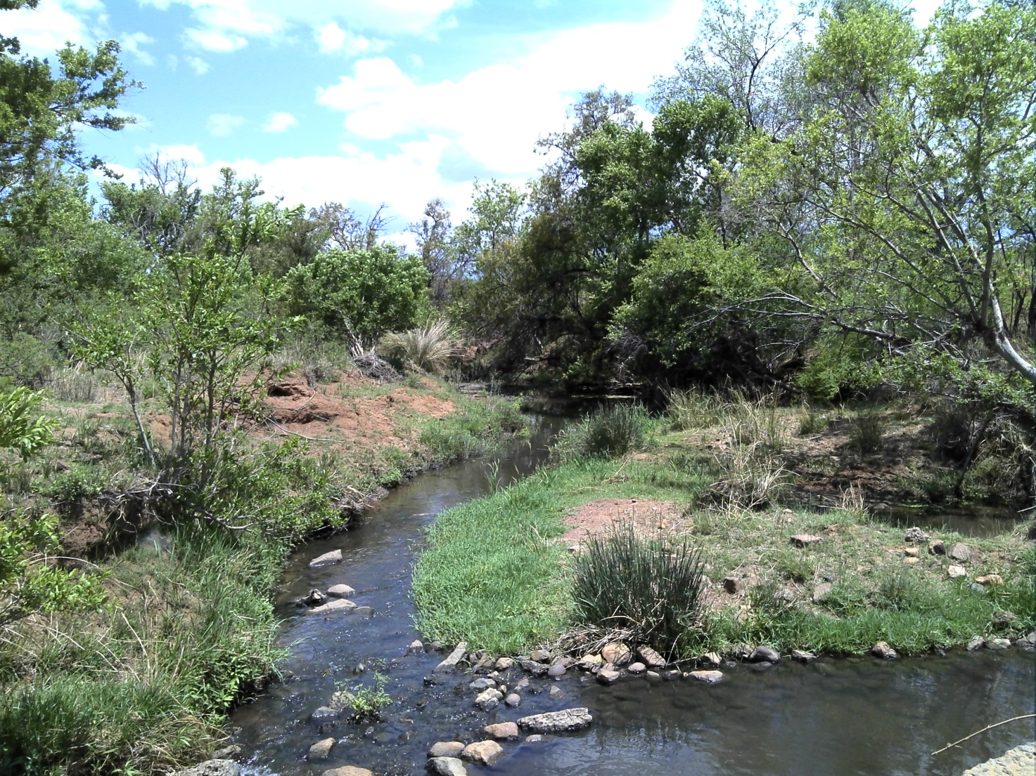

Figure 7: Main channel of the perennial river.

The PES (Present Ecological Score) of the riparian area together with all its drainage lines and tributaries was calculated using a level 3 VEGRAI assessment. The PES score was calculated as a C. Table 3 provides descriptions of the health scores.

Table 3: Generic ecological categories for EcoStatus components (modified from Kleynhans, 1996 & Kleynhans, 1999)

| **ECOLOGICAL**  **CATEGORY** | **DESCRIPTION** | **SCORE**  **(% OF TOTAL)** |
| --- | --- | --- |
| A | Unmodified, natural. | 90-100 |
| B | Largely natural with few modifications. A small change in natural habitats and biota may have taken place but the ecosystem functions are essentially unchanged. | 80-89 |
| **C** | **Moderately modified. Loss and change of natural habitat and biota have occurred, but the basic ecosystem functions are still predominantly unchanged.** | **60-79** |
| D | Largely modified. A large loss of natural habitat, biota and basic ecosystem functions has occurred. | 40-59 |
| E | Seriously modified. The loss of natural habitat, biota and basic ecosystem functions is extensive. | 20-39 |
| F | Critically modified. Modifications have reached a critical level and the lotic system has been modified completely with an almost complete loss of natural habitat and biota. In the worst instances the basic ecosystem functions have been destroyed and the changes are irreversible | 0-19 |

# Buffer Zones

A buffer zone is defined as a strip of land surrounding a wetland or riparian area in which activities are controlled or restricted (DWAF, 2005). A development has several impacts on the surrounding environment and on a watercourse. The development changes habitats, the ecological environment, infiltration rate, amount of runoff and runoff intensity of the site, and therefore the water regime of the entire site. A hard impervious surface such as parking areas, roads and roofs adjacent to the wetland or riparian area will block normal water flow to the wetland, while increasing storm water flow during a rainfall event. An increased volume of stormwater runoff, peak discharges, and frequency and severity of flooding is therefore often characteristic of transformed catchments.

Buffer zones have been shown to perform a wide range of functions and have therefore been widely proposed as a standard measure to protect water resources and their associated biodiversity. These include (i) maintaining basic hydrological processes; (ii) reducing impacts on water resources from upstream activities and adjoining landuses; (iii) providing habitat for various aspects of biodiversity. A brief description of each of the functions and associated services is outlined in Table 4 below.

Table 4: Generic functions of buffer zones relevant to the study site (adapted from Macfarlane *et al*, 2010)

| **Primary Role** | **Buffer Functions** |
| --- | --- |
| Maintaining basic aquatic processes, services and values. | * Groundwater recharge: Seasonal flooding into wetland areas allows infiltration to the water table and replenishment of groundwater. This groundwater will often discharge during the dry season providing the base flow for streams, rivers, and wetlands. |
| Reducing impacts from upstream activities and adjoining land uses | * Sediment removal: Surface roughness provided by vegetation, or litter, reduces the velocity of overland flow, enhancing settling of particles. Buffer zones can therefore act as effective sediment traps, removing sediment from runoff water from adjoining lands thus reducing the sediment load of surface waters. * Removal of toxics: Buffer zones can remove toxic pollutants, such hydrocarbons that would otherwise affect the quality of water resources and thus their suitability for aquatic biota and for human use. * Nutrient removal: Wetland vegetation and vegetation in terrestrial buffer zones may significantly reduce the amount of nutrients (N & P), entering a water body reducing the potential for excessive outbreaks of microalgae that can have an adverse effect on both freshwater and estuarine environments. * Removal of pathogens: By slowing water contaminated with faecal material, buffer zones encourage deposition of pathogens, which soon die when exposed to the elements. |

Despite limitations, buffer zones are well suited to perform functions such as sediment trapping, erosion control and nutrient retention which can significantly reduce the impact of activities taking place adjacent to water resources. Buffer zones are therefore proposed as a standard mitigation measure to reduce impacts of landuses / activities planned adjacent to water resources. These must however be considered in conjunction with other mitigation measures.

Local government policies require that protective buffer zones be calculated from the outer edge of the temporary zone of a wetland (KZN DAEA, 2002; CoCT, 2008; GDACE, 2009). Although research is underway to provide further guidance on appropriate defensible buffer zones, there is no current standard other than the generic recommendation of 50m for wetlands inside the urban edge. The current report suggests that a generic 50m buffer zone be applied to the edge of the wetland areas and 100m from the erdge of riparian habitat delineated in this report.

## Wetland input into Environmental Management Plan (EMP)

It is important to note that a Water Use Licence (WUL) issued from the Department of Water Affairs (DWA) is required for any structures that are placed within the 1:100 flood-line or within the edge of a riparian area as well as structures within 500m from a delineated wetland area (DWA, 2010).

Table 5 below indicates all the towers within 500m and/or 100m from the watercourses as well as the areas where the line will need to span across a watercourse. A brief summary of potential impacts is provided in this table. The towers within 500m from a watercourse are indicated for mitigation purposes, as a 500m buffer zone from the edge of the riparian area is considered as potentially sensitive to activities associated with construction. All the towers within a 100m buffer zone are highlighted due to potential implications of General Notice 1199 of the National Water Act, 1998 (Act 36 of 1998) and may require a water use license. This legislation is also applicable to activities (including access roads) that are located within the 1:100 year floodline or riparian habitat (whichever is the greatest) (DWA, 2010).

Table 5: The impacts associated with the various watercourses along the power line.

| **Tower number**  **(756kV)** | **Tower Number**  **(400kV)** | **Classification of Watercourses (NWA, 1998) observed during the field survey** | **Notes** | **Present Ecological State (PES) \*** |
| --- | --- | --- | --- | --- |
| 341 | 327 | * Within 500m from a drainage line | * Should be regarded as sensitive area. * Follow best practice principles | **C** |
| 342 | 328 | * Within 100m of a drainage line. * 342 Located directly within the drainage line | * Tower 342 should be moved so it is not located directly within the drainage line. * Mitigation for erosion should be followed. * Where necessary, soil compaction, sedimentation and loss of natural vegetation should be rehabilitated. * Monitor for establishment of alien invasive vegetation. | **C** |
| 343, 344, 345 | 329, 330, 331 | * Within 500m of a riparian area. | * On the 765kV line the line will span the riparian area between the following towers: 342 & 343. * On the 400kV line the line will span the riparian area between the following towers: 328 & 329. * Care should be taken not to drive though these areas. * Where necessary, soil compaction and loss of natural vegetation should be rehabilitated. | **C** |
| 345, 346, 347 | 331, 332, 333 | * Within 500m of a drainage line. | * Follow best practice principles | **C** |
| 351, 352, 353, 354, 355, 356, 357, 358,359, 360, 361, 362, 363, 364 | 336, 337, 341, 342, 344, 345, 346, 347 | * Within 500m of a drainage line. | * On the 765kV line the line will span the drainage line between the following towers: 351 & 352, 358 & 361, 362 &363. * On the 400kV line the line will span the drainage line between the following towers: 336 & 337, 342 & 344, 346 & 347. * Care should be taken not to drive though these areas. * Where necessary, soil compaction and loss of natural vegetation should be rehabilitated. | **C** |
| 358, 360 | 342, 344, 346 | * Within 100m of the Drainage Line | * Erosion mitigations should be followed. | **C** |
| 359 | 343 | * Located directly within a drainage line. | * Towers should be moved so it is not located directly within the drainage line. * Mitigation for erosion should be followed. * Where necessary, soil compaction, sedimentation and loss of natural vegetation should be rehabilitated. * Monitor for establishment of alien invasive vegetation. | **C** |
| 373, 374, 375, 376 | 356, 357, 358, 359 | * Located within 500m of an unchannelled valley bottom wetland. | * On the 765kV line the line will span the wetland between the following towers: 373 & 375 * On the 400kV line the line will span the wetland between the following towers: 357 7 358. * Care should be taken not to drive though these areas. * Where necessary, soil compaction and loss of natural vegetation should be rehabilitated. | **C** |
| 374 |  | * Located directly within a unchannelled valley bottom wetland | * Tower should be moved so it is not located directly within the wetland or its buffer zone. * Mitigation for erosion should be followed. * Where necessary, soil compaction and loss of natural vegetation should be rehabilitated. | **C** |
| 376, 377, 378 | 359, 360, 361 | * Located within 500m of a seepage wetland. | * On the 765kV line the line will span the wetland including its buffer zone between the following towers: 377 & 378 * On the 400kV line the line will span the wetland and its buffer zone between the following towers: 360 & 361. * Care should be taken not to drive though these areas. * Where necessary, soil compaction and loss of natural vegetation should be rehabilitated. | **C/D** |
| 391, 392, 393, 394 | 373, 374, 375 | * Located within 500m of a seepage wetland | * On the 765kV line the line will span the wetland and its buffer zone between the following towers: 391 & 393. * On the 400kV line the line will span the wetland and its buffer zone between the following towers: 373 & 374. * Care should be taken not to drive though these areas. * Where necessary, soil compaction and loss of natural vegetation should be rehabilitated. | **C** |
| 392 | 374 | * 392 Located directly within a seepage wetland. * 374 located very close to a seepage wetland. | * Towers should be moved so they are not located directly within the wetland or its buffer. * Where necessary, soil compaction and loss of natural vegetation should be rehabilitated. * Mitigation for erosion should be followed. | **C/D** |
| 392, 393, 394 | 374, 375 | * Located within 500m of a riparian area. | * On the 765kV line the line will span the riparian area between the following towers: 393 & 394. * On the 400kV line the line will span the riparian area between the following towers: 374 & 375. * Care should be taken not to drive though these areas. * Where necessary, soil compaction and loss of natural vegetation should be rehabilitated. | **C** |
| 393 | 375 | * Located within 100m of a riparian area. | * Mitigation for erosion should be followed. | **C** |
| 399, 400, 401, 402, 403, 404 | 380, 381, 382, 383, 384, 385 | * Located within 500m of a riparian area | * On the 765kV line the line will span the riparian area between the following towers: 401 & 402, 403 & 404. * On the 400kV line the line will span the riparian area between the following towers: 380 & 381, 383 & 384. * Care should be taken not to drive though these areas. * Where necessary, soil compaction and loss of natural vegetation should be rehabilitated. | **C** |
| 400, 401, 403, 404 | 381, 383, 384 | * Located within 100m of a riparian area. | * Mitigation for erosion should be followed. | **C** |
| 409, 410, 411 | 389, 390 | * Located within 500m of a drainage line. | * On the 765kV line the line will span the drainage line between the following towers: 409 & 410. * On the 400kV line the line will span the drainage line between the following towers: 389 & 390. * Care should be taken not to drive though these areas. | **C** |
| 410 |  | * Located within 100m of a drainage line. | * Mitigation for erosion should be followed. | **C** |
| 414, 415 | 393, 394 | * Located within 500m of a drainage line | * On the 765kV line the line will span the drainage line between the following towers: 414 & 415 * On the 400kV line the line will span the drainage line between the following towers: 393 & 394. * Care should be taken not to drive though these areas. * Where necessary, soil compaction and loss of natural vegetation should be rehabilitated. | **C** |
| 414 | 393 | * Located within 100m of a drainage line. | * Mitigation for erosion should be followed. | **C** |
| 414, 415, 416, 417, 418, 419, 420, 421, 422, 423, 424, 425, 426, 427, 428, 429, 430, 431, 432, 433, 434, 435 | 393, 394, 395, 396, 397, 398, 399, 400, 401, 402, 403, 404, 405, 406, 407, 408, 409, 410, 411, 413, 414, 415, 416, 417 | * Located within 500m of a riparian area or one of the associated tributaries or drainage lines. | * On the 765kV line the line will span the riparian area between the following towers: 417 & 418, 422 & 423, 424 & 425, 426 & 427, 428 & 429, 432 & 433, 433 & 434. * On the 400kV line the line will span the riparian area between the following towers: 393 & 394, 402 & 403, 404 & 405, 406 & 407, 408 & 409, 412 & 414. * Care should be taken not to drive though these areas. * Where necessary, soil compaction and loss of natural vegetation should be rehabilitated. | **C** |
| 417, 418, 422, 423, 424, 427, 428, 429, 433 | 397, 398, 407, 408, 409, 414 | * Located within 100m of a riparian area or one of the associated tributaries or drainage lines. | * Mitigation for erosion should be followed. | **C** |
| 425 | 405, 413 | * Located directly within a riparian area or one of the associated tributaries or drainage lines. | * Towers should be moved so it is not located directly within the drainage line. * Mitigation for erosion should be followed. | **C** |

* PES for wetlands was calculated using a Level 1 Wet-Health Assessment. PES for riparian areas and Drainage lines was calculated using a Level 3 VEGRAI (riparian Vegetation Response Assessment Index) Assessment.

Tables 6 and 7 provide more detail regarding mitigation and management procedures of impacts for all towers and more specifically for the towers highlighted above.

Table 6: Minimum suggested mitigation measures.

| **Tower numbers** | **Mitigation** |
| --- | --- |
| All towers | Erosion Control:   * The contractor shall be responsible for rehabilitating all eroded areas in such a way that the erosion potential is minimised after construction has been completed * All slopes that are disturbed during construction should be stabilised immediately to prevent erosion * Re-vegetation should be done immediately after construction, especially in sloped areas * Disturbances on site should be kept to a minimum to reduce the loss of material by erosion * Disturbed areas that require rehabilitation should be mulched to encourage vegetation re-growth. * Stockpiled soil should be protected from erosion due to water runoff * Near vertical slopes of 1(V):1(H) or 1(V):2(H) must be stabilised using hard structures, preferably with a natural look, and with facilities allowing for plant growth. The EO / ECO will specify a solution in terms of the most appropriate approved method and technology. One or more of the following methods may be required: * Retaining walls (loffel or otherwise) (DWAF 2005) * Stone pitching. * Gabions. * Shotcrete. * Protect the slopes of all river diversions. One or more of the following methods may be used, as specified by the EO / ECO: (DWAF, 2005) * Sandbags. * Reno mattresses. * Plastic liners and / or coarse rock (undersize rip-rap) * Protect all areas susceptible to erosion and ensure that there is no undue soil erosion resultant from activities within work areas * Sensitive areas such as watercourses (wetlands, pans, and riparian areas) should be cordoned off so that vehicles and construction personnel cannot gain access to these areas. * Where access cannot be avoided into sensitive areas, the amount of vehicle and personnel traffic should be kept to a minimum and should make use of only one route * Where crossings of watercourses are unavoidable eco-friendly soft options (such as wooden poles) should be placed over the wet area to be driven over * Where all preventative measures have failed and erosion persists soft and hard rehabilitation options, such as eco-logs or weirs, should be considered in conjunction with an engineer and wetland specialist * Erosion control of all banks must take place so as to reduce erosion and sedimentation into river channels or wetland areas.   Soil compaction:   * Areas where soil has been compacted should be ripped to encourage vegetation growth * Ripping shall be done to a depth of 250 mm in two directions at right angles. * Do not rip and / or scarify areas under wet conditions, as the soil will not break up and compaction will be worsened * Do not permit vehicular or pedestrian access into natural areas or into seasonally wet areas during and immediately after rainy periods, until such a time that the soil has dried out (DAWF, 2005)   Rip and / or scarify all disturbed (and other specified) areas of the construction site, including temporary access routes and roads, compacted during the execution of the Works. (DWAF, 2005)  General:   * In case of emergencies or unforeseen events the problem must be remediated immediately and any spillage into any watercourses be reported to the Department of Water Affairs. In addition, the soil must be stabilised (import additional topsoil if necessary) and re-vegetated as soon as possible. Re-vegetation should include seeds from the adjacent grassland and any rescued protected plants and/or plants of conservation concern that might have been impacted upon by the emergency / unforeseen event. * Sedimentation should be prevented though sufficient mitigation * If structures are used on sensitive sloped areas it is important that sediment does not pass through these structures e.g. gabions should be lined * Should sedimentation be observed to accumulate and smother vegetation, a wetland specialist should be consulted to find a suitable solution for the specific wetland and its species composition. |

Table 7: Impacts and suggested management procedures relevant to the proposed development (modified from Macfarlane *et al*, 2010)

| **Threat / Impact** | **Source of the threat** | **Primary Management Procedure** |
| --- | --- | --- |
| Changing the quantity and fluctuation properties of the watercourse.  765kV Tower Numbers:  342, 343, 351, 352, 358-363, 373, 375, 377, 378, 391-394, 401-404, 409, 410, 415-418, 422-429, 432-434.  400kV Tower Numbers:  328, 329, 336, 337, 342-344, 346, 347, 357, 358, 360, 361, 373, 374, 375, 380, 381, 383, 384, 389, 390, 393, 394, 402-409, 412-414., | *Construction:*   * Development within water resources e.g. tower footprint within wetland area or riparian area, thereby diverting or impeding flow * Lack of adequate rehabilitation resulting in invasion by woody invasive plants   *Operational:*   * Vehicles driving in / through watercourses   Damage to vegetated areas | * No activities should take place in the watercourses and associated buffer zone. Where the above is unavoidable, only a pylon footprint and no access roads can be considered. This is subjected to authorization by means of a water use license. * Construction in and around watercourses must be restricted to the dryer winter months. * A temporary fence or demarcation must be erected around the works area to prevent access to sensitive environs. The works areas generally include the servitude, construction camps, areas where material is stored and the actual footprint of the tower/pylon * Prevent pedestrian and vehicular access into the wetland and buffer areas as well as riparian areas. * No vehicle access is allowed within watercourses, not even to pull the electricity cables through * Access roads and bridges should span the wetland area, without impacting on the permanent or seasonal zones * Formalise access roads and make use of existing roads and tracks where feasible, rather than creating new routes through naturally vegetated areas. * Management of on-site water use and prevent stormwater or contaminated water directly entering the watercourse * Management of point discharges * Planning of construction site must include eventual rehabilitation / restoration of indigenous vegetative cover * Alien plant eradication and follow-up control activities prior to construction, to prevent spread into disturbed soils, as well as follow-up control during construction * The amount of vegetation removed should be limited to the least amount possible. * Rehabilitation plans must be submitted and approved for rehabilitation of damage during construction and that plan must be implemented immediately upon completion of construction. |
| Changing the amount of sediment entering water resource and associated change in turbidity (increasing or decreasing the amount)  765kV Tower Numbers:  342, 358-360, 374, 392, 393, 400-404, 410, 414, 417, 418, 422-425, 427-429, 433.  400kV Tower Numbers:  328, 342-344, 346, 374, 375, 389, 390, 393, 397, 398, 407-409, 413, 414. | Construction:   * Earthwork activities to construct towers. * Clearing of surface vegetation will expose the soils, which in rainy events would wash down into wetlands, causing sedimentation. In addition, indigenous vegetation communities are unlikely to colonise eroded soils successfully and seeds from proximate alien invasive trees can spread easily into these eroded soil. * Disturbance of soil surface * Disturbance of slopes through creation of roads and tracks * Changes in runoff characteristics * Erosion (e.g. gully formation, bank collapse)   *Operational:*  Vehicles impacting on surface vegetation | * Construction in and around watercourses must be restricted to the dryer winter months. * A temporary fence or demarcation must be erected around the works area to prevent water runoff and erosion of the disturbed or heaped soils into wetland areas. * Access roads and bridges should span the wetland area, without impacting on the permanent or seasonal zones. * Formalise access roads and make use of existing roads and tracks where feasible, rather than creating new routes through naturally vegetated areas. * Retain vegetation and soil in position for as long as possible, removing it immediately ahead of construction / earthworks in that area (DWAF, 2005). * A vegetation rehabilitation plan should be implemented. Grassland can be removed as sods and stored within transformed vegetation. The sods must preferably be removed during the winter months and be replanted by latest springtime. The sods should not be stacked on top of each other or within sensitive environs. Once construction is completed, these sods should be used to rehabilitate the disturbed areas from where they have been removed. In the absence of timely rainfall, the sods should be watered well after planting and at least twice more over the next 2 weeks. * Remove only the vegetation where essential for construction and do not allow any disturbance to the adjoining natural vegetation cover. * Rehabilitation plans must be submitted and approved for rehabilitation of damage during construction and that plan must be implemented immediately upon completion of construction. * Cordon off areas that are under rehabilitation as no-go areas using danger tape and steel droppers. If necessary, these areas should be fenced off to prevent vehicular, pedestrian and livestock access. * Delay the re-introduction of livestock (where applicable) to all rehabilitation areas until an acceptable level of re-vegetation has been reached. * During the construction phase measures must be put in place to control the flow of excess water so that it does not impact on the surface vegetation. * Protect all areas susceptible to erosion and ensure that there is no undue soil erosion resultant from activities within and adjacent to the construction camp and work areas. * Runoff from roads must be managed to avoid erosion and pollution problems. * Implementation of best management practices * Source-directed controls * Buffer zones to trap sediments * Active rehabilitation |
| Alteration of water quality – toxic contaminants (including toxic metal ions (e.g. copper, lead, zinc) and hydrocarbons.  765kV Tower Numbers:  342, 358-360, 374, 392, 393, 400-404, 410, 414, 417, 418, 422-425, 427-429, 433.  400kV Tower Numbers:  328, 342-344, 346, 374, 375, 389, 390, 393, 397, 398, 407-409, 413, 414. | Construction:   * Runoff from road surfaces * Runoff from cultivated lands * Discharge of solvents, and other industrial chemicals   *Operational:*   * Runoff from road surfaces * Discharge of solvents, and other industrial chemicals | * After construction, the land must be cleared of rubbish, surplus materials, and equipment, and all parts of the land shall be left in a condition as close as possible to that prior to use. * Ensure that maintenance work does not take place haphazardly, but, according to a fixed plan, from one area to the other. * Maintenance of construction vehicles * Control of waste discharges * Guidelines for implementing Clean Technologies * Maintenance of buffer zones to trap sediments with associated toxins |
| Changing the physical structure within a water resource (habitat)  765kV Tower Numbers:  342, 359, 374, 392, 425.  400kV Tower Numbers:  343, 374, 405, 413. | Construction:   * Encroachment to achieve maximum commercial returns * Deposition of wind-blown sand * Loss of fringing vegetation and erosion * Alteration in natural fire regimes   *Operational:*  Loss of vegetation | * Other than approved and authorized structure, no other development or maintenance infrastructure is allowed within the delineated wetland and riparian areas or their associated buffer zones. * Demarcate the wetlands and riparian areas and buffer zones to limit disturbance, clearly mark these areas as no-go areas * Linear developments (e.g. roads) should span the watercourse * Weed control in buffer zone * Monitor rehabilitation and the occurrence of erosion twice during the rainy season for at least two years and take immediate corrective action where needed. * Monitor the establishment of alien invasive species within the areas affected by the construction and maintenance of the powerline and take immediate corrective action where invasive species are observed to establish. |

# CONCLUSION

One riparian area and three wetland areas was recorded on this section of the proposed line. Drainage lines were also mapped although they do not fall into the definition of either wetland or riparian habitat. They do however form part of the hydrological environment and as such should be considered as sensitive features.

The riparian area and its associated drainage lines and tributaries extend for the majority of the proposed 40km line and transverses the line in several places. The riparian area further flows parallel with the proposed line for approximately 17km. The majority of the riparian vegetation is intact and creates a sufficient buffer against natural erosional features and sedimentation. However should this vegetation be removed it is likely that erosion and sedimentation will increase in those areas. The majority of the drainage lines that recorded are non-perennial drainage lines while the main river channel appears to be a perennial river. The wetlands recorded have been somewhat disturbed by anthropogenic activities such as roads, farming and water treatment facilities. All the wetland areas also show signs of grazing and construction activities have taken place in two of the wetland areas and thus have resulted in a lower PES score for these wetland areas.

A development has several impacts on the surrounding environment and particularly on wetlands and riparian areas. The proposed development will likely change habitats, the ecological environment, infiltration rates, amount of runoff and runoff intensity of stormwater, and therefore the hydrological regime of the site. It is important to note that a Water Use Licence issued from the Department of Water Affairs is required for any structures that are placed within the 1:100 flood-line or within the edge of a riparian area as well as structures within 500m from a delineated wetland area (DWA, 2010).

A summary of the affected towers is recorded in Table 8 below.

Table 8: The impacts associated with the various watercourses along the power line

| **Tower number**  **(756kV)** | **Tower Number**  **(400kV)** | **Classification of Watercourses (NWA, 1998) observed during the field survey** | **Notes** | **Present Ecological State (PES) \*** |
| --- | --- | --- | --- | --- |
| 341 | 327 | * Within 500m from a drainage line | * Should be regarded as sensitive area. * Follow best practice principles | **C** |
| 342 | 328 | * Within 100m of a drainage line. * 342 Located directly within the drainage line | * Tower 342 should be moved so it is not located directly within the drainage line. * Mitigation for erosion should be followed. * Where necessary, soil compaction, sedimentation and loss of natural vegetation should be rehabilitated. * Monitor for establishment of alien invasive vegetation. | **C** |
| 343, 344, 345 | 329, 330, 331 | * Within 500m of a riparian area. | * On the 765kV line the line will span the riparian area between the following towers: 342 & 343. * On the 400kV line the line will span the riparian area between the following towers: 328 & 329. * Care should be taken not to drive though these areas. * Where necessary, soil compaction and loss of natural vegetation should be rehabilitated. | **C** |
| 345, 346, 347 | 331, 332, 333 | * Within 500m of a drainage line. | * Follow best practice principles | **C** |
| 351, 352, 353, 354, 355, 356, 357, 358,359, 360, 361, 362, 363, 364 | 336, 337, 341, 342, 344, 345, 346, 347 | * Within 500m of a drainage line. | * On the 765kV line the line will span the drainage line between the following towers: 351 & 352, 358 & 361, 362 &363. * On the 400kV line the line will span the drainage line between the following towers: 336 & 337, 342 & 344, 346 & 347. * Care should be taken not to drive though these areas. * Where necessary, soil compaction and loss of natural vegetation should be rehabilitated. | **C** |
| 358, 360 | 342, 344, 346 | * Within 100m of the Drainage Line | * Erosion mitigations should be followed. | **C** |
| 359 | 343 | * Located directly within a drainage line. | * Towers should be moved so it is not located directly within the drainage line. * Mitigation for erosion should be followed. * Where necessary, soil compaction, sedimentation and loss of natural vegetation should be rehabilitated. * Monitor for establishment of alien invasive vegetation. | **C** |
| 373, 374, 375, 376 | 356, 357, 358, 359 | * Located within 500m of an unchannelled valley bottom wetland. | * On the 765kV line the line will span the wetland between the following towers: 373 & 375 * On the 400kV line the line will span the wetland between the following towers: 357 7 358. * Care should be taken not to drive though these areas. * Where necessary, soil compaction and loss of natural vegetation should be rehabilitated. | **C** |
| 374 |  | * Located directly within a unchannelled valley bottom wetland | * Tower should be moved so it is not located directly within the wetland or its buffer zone. * Mitigation for erosion should be followed. * Where necessary, soil compaction and loss of natural vegetation should be rehabilitated. | **C** |
| 376, 377, 378 | 359, 360, 361 | * Located within 500m of a seepage wetland. | * On the 765kV line the line will span the wetland including its buffer zone between the following towers: 377 & 378 * On the 400kV line the line will span the wetland and its buffer zone between the following towers: 360 & 361. * Care should be taken not to drive though these areas. * Where necessary, soil compaction and loss of natural vegetation should be rehabilitated. | **C/D** |
| 391, 392, 393, 394 | 373, 374, 375 | * Located within 500m of a seepage wetland | * On the 765kV line the line will span the wetland and its buffer zone between the following towers: 391 & 393. * On the 400kV line the line will span the wetland and its buffer zone between the following towers: 373 & 374. * Care should be taken not to drive though these areas. * Where necessary, soil compaction and loss of natural vegetation should be rehabilitated. | **C** |
| 392 | 374 | * 392 Located directly within a seepage wetland. * 374 located very close to a seepage wetland. | * Towers should be moved so they are not located directly within the wetland or its buffer. * Where necessary, soil compaction and loss of natural vegetation should be rehabilitated. * Mitigation for erosion should be followed. | **C/D** |
| 392, 393, 394 | 374, 375 | * Located within 500m of a riparian area. | * On the 765kV line the line will span the riparian area between the following towers: 393 & 394. * On the 400kV line the line will span the riparian area between the following towers: 374 & 375. * Care should be taken not to drive though these areas. * Where necessary, soil compaction and loss of natural vegetation should be rehabilitated. | **C** |
| 393 | 375 | * Located within 100m of a riparian area. | * Mitigation for erosion should be followed. | **C** |
| 399, 400, 401, 402, 403, 404 | 380, 381, 382, 383, 384, 385 | * Located within 500m of a riparian area | * On the 765kV line the line will span the riparian area between the following towers: 401 & 402, 403 & 404. * On the 400kV line the line will span the riparian area between the following towers: 380 & 381, 383 & 384. * Care should be taken not to drive though these areas. * Where necessary, soil compaction and loss of natural vegetation should be rehabilitated. | **C** |
| 400, 401, 403, 404 | 381, 383, 384 | * Located within 100m of a riparian area. | * Mitigation for erosion should be followed. | **C** |
| 409, 410, 411 | 389, 390 | * Located within 500m of a drainage line. | * On the 765kV line the line will span the drainage line between the following towers: 409 & 410. * On the 400kV line the line will span the drainage line between the following towers: 389 & 390. * Care should be taken not to drive though these areas. | **C** |
| 410 |  | * Located within 100m of a drainage line. | * Mitigation for erosion should be followed. | **C** |
| 414, 415 | 393, 394 | * Located within 500m of a drainage line | * On the 765kV line the line will span the drainage line between the following towers: 414 & 415 * On the 400kV line the line will span the drainage line between the following towers: 393 & 394. * Care should be taken not to drive though these areas. * Where necessary, soil compaction and loss of natural vegetation should be rehabilitated. | **C** |
| 414 | 393 | * Located within 100m of a drainage line. | * Mitigation for erosion should be followed. | **C** |
| 414, 415, 416, 417, 418, 419, 420, 421, 422, 423, 424, 425, 426, 427, 428, 429, 430, 431, 432, 433, 434, 435 | 393, 394, 395, 396, 397, 398, 399, 400, 401, 402, 403, 404, 405, 406, 407, 408, 409, 410, 411, 413, 414, 415, 416, 417 | * Located within 500m of a riparian area or one of the associated tributaries or drainage lines. | * On the 765kV line the line will span the riparian area between the following towers: 417 & 418, 422 & 423, 424 & 425, 426 & 427, 428 & 429, 432 & 433, 433 & 434. * On the 400kV line the line will span the riparian area between the following towers: 393 & 394, 402 & 403, 404 & 405, 406 & 407, 408 & 409, 412 & 414. * Care should be taken not to drive though these areas. * Where necessary, soil compaction and loss of natural vegetation should be rehabilitated. | **C** |
| 417, 418, 422, 423, 424, 427, 428, 429, 433 | 397, 398, 407, 408, 409, 414 | * Located within 100m of a riparian area or one of the associated tributaries or drainage lines. | * Mitigation for erosion should be followed. | **C** |
| 425 | 405, 413 | * Located directly within a riparian area or one of the associated tributaries or drainage lines. | * Towers should be moved so it is not located directly within the drainage line. * Mitigation for erosion should be followed. | **C** |

The towers that are likely to have the largest impacts on the watercourses recorded are those that are located directly within the wetland or riparian areas (765kV Tower Numbers: 342, 359, 374, 392, 425 and 400kV Tower Numbers: 343, 374, 405, and 413). Ideally these towers should be moved out of the watercourse to minimise potential erosion and sedimentation. The towers that will need to span watercourses are: 765kV Tower Numbers: 342, 343, 351, 352, 358-363, 373, 375, 377, 378, 391-394, 401-404, 409, 410, 415-418, 422-429, 432-434 and 400kV Tower Numbers: 328, 329, 336, 337, 342-344, 346, 347, 357, 358, 360, 361, 373, 374, 375, 380, 381, 383, 384, 389, 390, 393, 394, 402-409, 412-414. Care should be taken not to drive through these watercourses as it is likely to cause erosion, sedimentation and loss of vegetation.

In order to limit the impact on the hydrology of the area, the current assessment finds that a 50m buffer zone should be recognised from the edge of all wetlands and 100m from the edge of riparian areas. Powerline infrastructure should ideally be excluded from these sensitive areas. However, linear developments such as the proposed powerline are rarely able to avoid crossing any watercourses whatsoever. Where alternatives have been investigated and watercourse crossings have been shown to be necessary it is important that appropriate mitigation measures are put into place and carefully monitored to ensure minimal impact to regional hydrology. In the case of the proposed powerline mitigation should focus on:

* Rehabilitation / restoration of indigenous vegetative cover;
* Management of point discharges during construction activities;
* Alien plant control;
* Implementation of best management practices regarding stormwater and earthworks;
* Provision of adequate sanitation facilities located outside of the wetland/riparian area or its associated buffer zone during construction activities;
* Implementation of appropriate stormwater management around the excavation to prevent the ingress of run-off into the excavation; and
* Prevention of erosion, and where necessary rehabilitation of eroded areas.

# REFERENCES

Armstrong A. (2009). WET-Legal:Wetland rehabilitation and the law in South Africa. WRC Report TT 338/09. Water research Comission, Pretoria

Brinson, M. (1993). A hydrogeomorphic classification for wetlands. Prepared for US Army Corps of Engineers. 101pp. Wetlands Research Programme Technical Report WRP-DE-4

Bromilow C. (2001). Problem Plants of South Africa. Briza Publications CC

Department of Water Affairs (2010). National Water Act, 1998 (Act No 36 of 1998) S21(c) & (i) Water Uses. Version: February 2010. Training Manual.

Department of Water Affairs and Forestry (2005). A practical field procedure for identification and delineation of wetlands and riparian areas. Department of Water affairs and Forestry. Pretoria. South Africa

Department of Water Affairs and Forestry (2007). Manual for the assessment of a Wetland Index of Habitat Integrity for South African floodplain and channelled valley bottom wetland types by M. Rountree (ed); C.P Todd, C. J. Kleynhans, A. L. Batchelor, M. D. Louw, D. Kotze, D. Walters, S. Schroeder, P. Illgner, M. Uys. and G.C. Marneweck. Report no. N/0000/00/WEI/0407. Resource Quality Services, Department of Water Affairs and Forestry, Pretoria, South Africa

Department of Water Affairs and Forestry (1999). Resource Directed Measures for Protection of Water Resources. Volume 4. Wetland Ecosystems Version 1.0. Pretoria

Ekurhuleni Biodiversity and Open Space Strategy (2009): Ekurhuleni Biodiversity and Open Space Strategy Prepared by Environomics, in association with MetroGIS, DVZ Consultants and David Hoare. Prepared for the Ekurhuleni Metro Municipality. May 2009.

Ewart-Smith J., Ollis D., Day J. and Malan H. (2006). National Wetland Inventory: Development of a Wetland Classification System for South Africa. Water Research Council project number K8/652

Ferrar, A.A. & Lötter, M.C. (2007). Mpumalanga Biodiversity Conservation Plan Handbook. Mpumalanga Tourism & Parks Agency, Nelspruit.

Fey M. (2005). Soils of South Africa: Systematics and environmental significance. Lombardi Trust. Draft submitted for comment

Fey M. (2010). Soils of South Africa: The distribution, properties, classification, genesis, use and environmental significance.

Gauteng Department of Agriculture Conservation & Environment (2002). Gauteng Agricultural Potential Atlas. Johannesburg

Gauteng Department of Agriculture and Rural Development (2012): Minimum Requirements for Biodiversity Assessments Version 2. Directorate Nature Conservation, Johannesburg.

Gauteng Department of Agriculture and Rural Development, (2011): Gauteng Conservation Plan Version 3 ArcGIS Spatial data

Kotze D C, 1999. A system for supporting wetland management decisions. Ph.D. thesis. School of Applied Environmental Sciences, University of Natal, Pietermaritzburg.

Kotze D.C., Marneweck, G.C., Batchelor, A.L., Lindley, D.S. and Collins, N.B. (2005). WET-EcoServices: A technique for rapidly assessing ecosystem services supplied by wetlands

Macfarlane D.M., Kotze D.C., Ellery W.N., Walters D, Koopman V, Goodman P and Goge C. (2007). WET-Health: A technique for rapidly assessing wetland health. Water Research Commission, Pretoria

Macfarlane D.M., Teixeira-Leite A., Goodman P., Bate G and Colvin C. (2010) Draft Report on the Development of a Method and Model for Buffer Zone Determination. Water Research Commission project K5/1789. The Institute of Natural Resources and its Associates

Marneweck G C, and Batchelor A L, (2002). Wetland classification, mapping and inventory. In: PALMER R W, TURPIE J, MARNEWECK G C, and BATCHELOR A L. Ecological and economic evaluation of wetlands in the upper Olifants River Catchment, South Africa. WRC Report No. 1162/1/02. Water Research Commission, Pretoria

Mucina L., & Rutherford M. C. (2006). Vegetation Map of South Africa, Lesotho and Swaziland, 1:1 000 000 scale sheet maps. South African National Biodiversity Institute., Pretoria

Schultze R.E. (1997). South African Atlas of Agrohydrology and Climatology. Water Research Commission, Pretoria, Report TT82/96

# Appendix A: Location of Survey Points

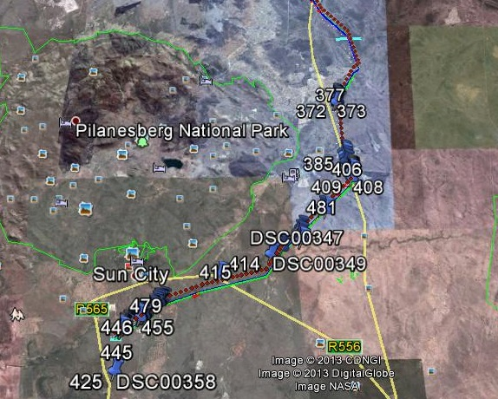

Figure 8: Sampling point map

# Appendix B: Glossary of Terms

|  |  |  |  |
| --- | --- | --- | --- |
| Anaerobic | not having molecular oxygen (O2) present | | |
| Buffer | A strip of land surrounding a wetland or riparian area in which activities are controlled or restricted, in order to reduce the impact of adjacent land uses on the wetland or riparian area | | |
| Gley | soil material that has developed under anaerobic conditions as a result of prolonged saturation with water. Grey and sometimes blue or green colours predominate but mottles (yellow, red, brown and black) may be present and indicate localised areas of better aeration | | |
| Hydrophyte | any plant that grows in water or on a substratum that is at least periodically deficient in oxygen as a result of soil saturation or flooding; plants typically found in wet habitats | | |
| Hydromorphic soil | soil that in its undrained condition is saturated or flooded long enough during the growing season to develop anaerobic conditions favouring the growth and regeneration of hydrophytic vegetation (vegetation adapted to living in anaerobic soils) | | |
| Mottles | soils with variegated colour patters are described as being mottled, with the "background colour" referred to as the matrix and the spots or blotches of colour referred to as mottles | | |
| Seepage | A type of wetland occurring on slopes, usually characterised by diffuse (i.e. unchannelled, and often subsurface) flows | | |
| Perched water table | the upper limit of a zone of saturation in soil, separated by a relatively impermeable unsaturated zone from the main body of groundwater | | |
| Permanently wet soil | soil which is flooded or waterlogged to the soil surface throughout the year, in most years | | |
| Sedges | Grass-like plants belonging to the family Cyperaceae, sometimes referred to as nutgrasses. Papyrus is a member of this family. | | |
| Soil horizons | layers of soil that have fairly uniform characteristics and have developed through pedogenic processes; they are bound by air, hard rock or other horizons (i.e. soil material that has different characteristics). | | |
| Soil profile | the vertically sectioned sample through the soil mantle, usually consisting of two or three horizons (Soil Classification Working Group, 1991) | | |
| Soil saturation | the soil is considered saturated if the water table or capillary fringe reaches the soil surface | | |
| Temporarily wet soil | The soil close to the soil surface (i.e. within 50 cm) is wet for periods > 2 weeks during the wet season in most years. However, it is seldom flooded or saturated at the surface for longer than a month. | | |
| Temporary zone of wetness | the outer zone of a wetland characterised by saturation within 50cm of the soil surface for less than three months in a year | | |
| Wetland: | “*land which is transitional between terrestrial and aquatic systems where the water table is usually at or near the surface, or the land is periodically covered with shallow water, and which land in normal circumstances supports or would support vegetation typically adapted to life in saturated soil*.” (National Water Act; Act 36 of 1998). | | |
| Wetland delineation | the determination and marking of the boundary of a wetland on a map using the DWAF (2005) methodology. This assessment includes identification of suggested buffer zones and is usually done in conjunction with a wetland functional assessment. The impact of the proposed development, together with appropriate mitigation measures are included in impact assessment tables | | |
|  | |  |

# 